CHEMICAL ENGINEERING TRANSACTIONS  VOL. 96, 2022 | A publication of
The Italian Association
of Chemical Engineering
Online at www.cetjournal.it

Guest Editors: David Bogle, Flavio Manenti, Piero Salatino
Copyright © 2022, AIDIC Servizi S.r.l.
ISBN 978-88-95608-95-2; ISSN 2283-9216

Feasibility study for the construction of a demonstration plant for the production of e-fuels
Franco Del Manso ^{a,}*, Simone Casadei, Davide Faedo, Angelo Lunghi, Gabriele Migliavacca ^{b}, Federico d’Amore ^{c} , Matteo C. Romano ^{c} , Davide Perego ^{d}
ª unem, P.le Luigi Sturzo, 31 - Roma, delmanso@unem.it
^{b} Innovhub SSI, Via Galilei, 3 - San Donato Milanese (MI)
^{c} Politecnico di Milano, Dipartimento di Energia, Via Lambruschini, 4, 20156 Milano (MI)
^{d} Politecnico di Milano, Energy & Strategy Group, Via Lambruschini, 4, 20156 Milano (MI)

Abstract

The production of e-fuels is mainly based on the synthesis processes of green hydrogen produced by the electrolysis of water (using renewable energy sources) and carbon dioxide (CO₂) which can be captured from a concentrated source (fumes of an industrial site), from the air (through Direct Air Capture, DAC solutions) or by exploiting the CO₂ of biogenic origin deriving from the production of biofuels. E-fuels can be considered climate-neutral fuels since the production process don’t release incremental CO₂ and, thanks to their compatibility with internal combustion engines, they can be used to power road vehicles, airplanes and ships, helping to decarbonise the transport sector.
E-fuels have an energy density much higher than that of batteries and therefore allow for the reduction of greenhouse gas emissions in transport, while preserving the current circulating fleet of vehicles. It is also possible to continue to use the transport, distribution and sales infrastructures nowadays in use for current liquid fuels as they are also perfectly compatible with e-fuels.
The project presented in this paper aimed to define the technical-economic parameters of a demonstrative pilot plant, able to produce sufficient quantities of e-fuels (Fischer-Tropsch) to carry out performance tests, as well as to evaluate the technical and economic potential for a future development in the Italian energy landscape.

  - Introduction

E-fuels are synthetic liquid or gaseous fuels, produced through the combination of CO₂ and H₂ from renewable sources to produce renewable fuels. The overall effect of the e-fuel production process is to transform renewable electricity and CO₂ into chemical energy in the form of climate-friendly fuels, which can be used as energy carriers (Dena, 2019) (Fratalocchi, 2020).
It is possible to classify e-fuels into two main categories:
1. Power-to-Gas (PtG), such as, eg. Hydrogen and Methane;
2. Power-to-Liquid (PtL), which includes, Gasoline, Diesel, Kerosene, Methanol, Ammonia, Dimethylether (DME), Polyoxymethylene dimethyl ether (OME), Olefins.

The e-fuels characteristics are very similar to those of the corresponding traditional ones and this makes them compatible both with the existing transport, distribution and storage infrastructure, and with the current end use systems (Frontier Economics, 2018).

The production of e-fuels also represents an important solution to the problem of long-term storage of energy produced from intermittent renewable sources. In Europe, the production of wind and photovoltaic energy is constantly increasing but is characterized by a strong intermittence in relation to weather conditions, based on daily, weekly and monthly variations. The amount of renewable electricity produced in excess of the grid demand can be efficiently stored for seconds, hours, days and weeks (e.g. in batteries), but convenient solutions for long-term storage are not yet available (O`Connell et. Al., 2019). Thanks to their high energy density, e-fuels can balance the intermittency of renewable electricity production (in large-scale stationary systems as well as in mobile tanks), integrating the traditional energy storage systems (Blanco and Faaij, 2018).

The production of e-fuels is mainly based on the synthesis processes of green hydrogen produced by the electrolysis of water (using renewable energy sources) and carbon dioxide (CO₂) which can be captured from a concentrated source (fumes of an industrial site), from the air (through Direct Air Capture, DAC solutions) or by exploiting the CO₂ of biogenic origin deriving from the production of biofuels. Therefore, e-fuels, not releasing incremental CO₂ in air, can be considered climate-neutral fuels and, thanks to their compatibility with internal combustion engines, can be used in road vehicles, airplanes and ships, helping to decarbonise the entire transport sector.
E-fuels have an energy density much higher than that of batteries and therefore allow for the reduction of greenhouse gas emissions in transport, while preserving the current circulating fleet of vehicles. It is also possible to continue to use the transport, distribution and sales infrastructures nowadays in use for current liquid fuels as they are also perfectly compatible with e-fuels.
The project aimed to carry out a process analysis to define the technical-economic parameters of a demonstration pilot plant, to study feasibility of the technology, to produce sufficient quantities of e-fuels (Fischer-Tropsch or e-FT) to conduct performance tests, as well as to evaluate the technical and economic potential for development in the Italian energy landscape.

The work officially began in February 2021 thanks to the collaboration between Innovhub SSI and the Politecnico di Milano. In particular:
- the GECOS Group of the Department of Energy carried out the technical-economic analysis of e-fuel production plants, defined the process specifications of the main components and estimated the investment and operating costs of the plant;
- the Energy & Strategy Group of the Department of Management Engineering was entrusted with the task of identifying and characterizing the economic variables associated with the construction of e-fuels production plants in Italy and to demonstrate the feasibility of the project.

The applied methodology and the main results of the project are briefly described in paragraphs 2,3 and 4.
  - Description of the pilot plant

In the first phase of the project, it was decided to consider a plant for the production of e-FT, starting from the production of H₂ through electrolysis of water at low temperatures. An example of a complete scheme of the pilot plant proposed for e-FT production is shown in Figure 1.

The make-up water is pumped at 30 bar and integrated with a flow of recirculated water from the system itself, also pumped at 30 bar, after proper treatment. The total flow of H₂O is fed into the low temperature electrolyser, which consumes electricity to generate O₂ and H₂. At the same time, a flow of CO₂ is mixed with a flow of recirculated CO₂ into the system and sent to a compression unit. Subsequently, the CO₂ compressed at 30 bar is mixed with the H₂ produced by electrolysis, then the overall flow is preheated (pre-heat1) to be fed to the reverse water gas shift (RWGS) reactor. The heat necessary to support the reactions inside the RWGS reactor is supplied by an electric heating system. The product of the RWGS reactor is cooled by preheating the flow entering in the reactor itself and is then further cooled with cooling water (cooler1), separating the fraction of water by condensation and recirculating it. The obtained syngas is sent to an amine based (MDEA) CO₂ separation system. The flow coming out of the CO₂ absorber is then mixed with a recirculation of light products which, once preheated (pre-heat2), constitutes the feed of the FT synthesis reactor.

During the simulation studies, different cases were analyzed on the basis of the H₂/CO ratio set at the inlet to the synthesis reactor and the results were evaluated in terms of mass and energy balance.

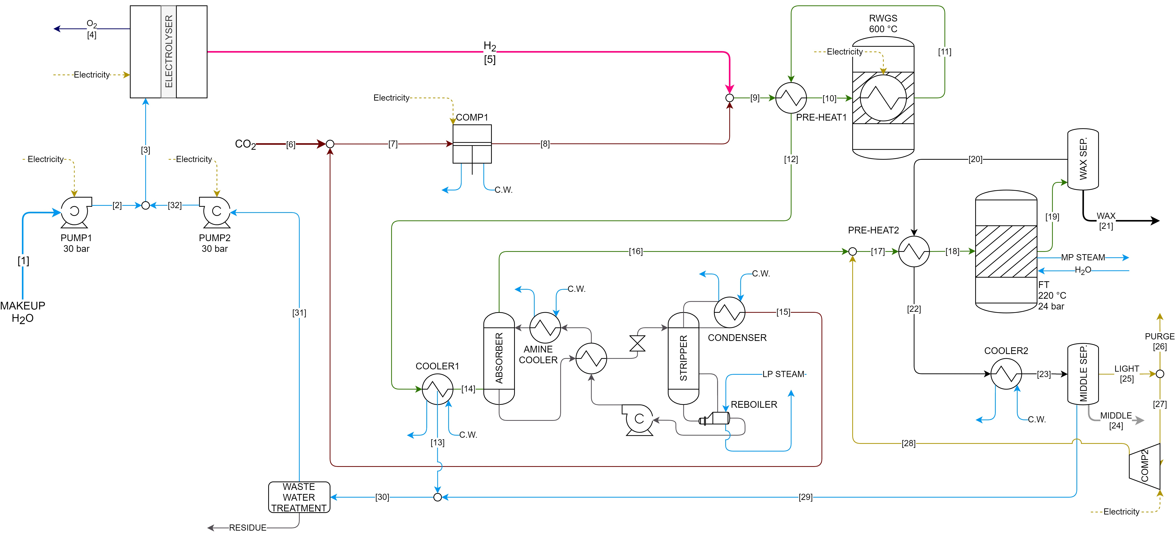
Figure 1. Process flow diagram of the pilot plant for FT synthesis and H₂ production by low temperature electrolysis

  - Mass and energy balances

Starting from the thermal balance of the most efficient plant investigated, it was observed that the electrical balance of the pilot plant is dominated by the consumption of electricity required by the electrolyser (approximately 94% of the total electricity consumption), followed by heating the RWGS reactor (3.6% of total consumption) and compression of CO₂ (2.3% of total consumption) (Figure 2).

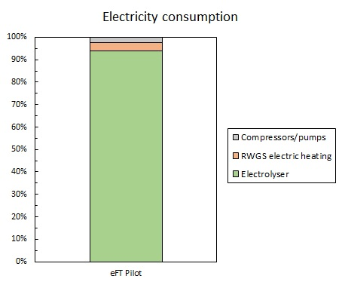
Figure 2. Breakdown of the overall electricity consumption of the pilot plant

In order to maximize the plant output in terms of syncrude production and, at the same time, to reduce specific consumption of H₂ and CO_{2,} the preliminary economic analysis was conducted on the most performing system considered. The size assumed for the pilot plant is approximately 5/6 barrels / day.
  - Preliminary economic analysis
For the calculation of the investment costs, the cost functions for coolers, electrical heating of the RWGS reactor, MDEA separation system and RWGS reactor were obtained respectively from Riva et al. (2018), Sternberg et al. (2015), IEAGHG (2017) and Zang et al. (2021).
The studied plant is characterized by a significant electricity consumption, mostly related to the electrolyser. As a consequence, the economic result of the pilot plant was evaluated considering various electricity prices. In particular, the electricity prices were set at 60 € / MWh, 100 € / MWh and 150 € / MWh.
Going from the assumed minimum (60 € / MWh) to the maximum price (150 € / MWh), there is an increase in variable operating costs from about 1500 € / day to almost 3700 € / day (+ 131%, Figure 3) and an increase of the total cost from approximately € 3.31 million to almost € 4.18 million (+ 26%, Figure 4).
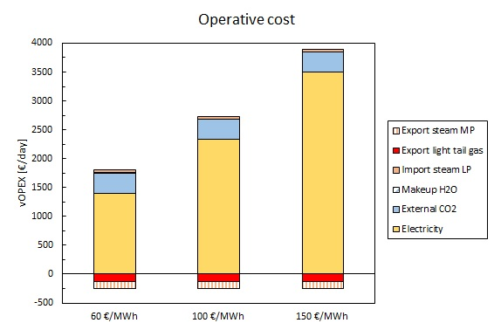
Figure 3. Effect of the change in the electricity prices (60 € / MWh, 100 € / MWh, 150 € / MWh) on variable operating costs (vOPEX = variable OPEX)

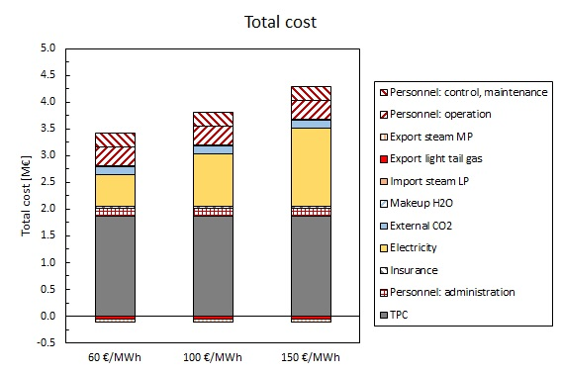
Figure 4. Effect of the change of electricity prices (60 € / MWh, 100 € / MWh, 150 € / MWh) on the total cost

These assumptions did not take into account the tensions on energy prices resulting from the current situation in Europe.

  - Conclusions

The technical-economic analysis carried out in this project confirms that the production of e-fuels is technically feasible using existing and relatively consolidated technologies. Nevertheless, the expected energy yields, meaning by this the percentage of electricity of renewable origin transformed into chemical energy stored in the e-fuel produced, are relatively modest and the predicted production costs are significantly higher than those of conventional fossil fuels. These criticalities could be balanced by the much lower need for huge infrastructure investments to ensure energy supply to the various transport sectors, compared to a full-electrification scenario. Furthermore, e-fuels have the main advantage of being usable in sectors that are difficult to electrify (air and sea transport) maintaining the existing vehicle fleet and, therefore, would allow a more rapid decarbonisation of those sectors without having to achieve a complete replacement of the fleets.
Nevertheless, since the overall efficiency of the process is a fundamental parameter to judge its validity and to guarantee its long-term sustainability in this study, we tried to select only those process and plant solutions which gave the best performance in terms of energy efficiency, reduction of CO₂ emissions and minimization of production costs.

References

Blanco, H., & Faaij, A., 2018, A review at the role of storage in energy systems with a focus on Power to Gas and long-term storage. Renewable and Sustainable Energy Reviews, 81, 1049-1086.
Dena, 2019. Powerfuels: Missing Link to a successful global Energy Transition. Current state of technologies, markets, and politics – and start of a global dialogue. https://www.powerfuels.org/newsroom/publikationsdetailansicht/pub/powerfuels-a-missing-link-to-asuccessful-global-energy-transition/ accessed 24.07.2020
Fratalocchi L., Groppi G., Visconti C.G., Lietti L., Tronconi E., 2020, Adoption of 3D printed highly conductive periodic open cellular structures as an effective solution to enhance the heat transfer performances of compact Fischer-Tropsch fixed-bed reactors. Chemical Engineering Journal, 386, 123988.
Frontier Economics, 2018. International Aspects of a Power-to-X Roadmap. https://www.frontier-economics.com/media/2642/frontier-int-ptx-roadmap-stc-12-10-18-final-report.pdf accessed 24.07.2020
IEAGHG, 2017, Techno-Economic Evaluation of SMR Based Standalone (Merchant) Hydrogen Plant with CCS.
O`Connell, A., Prussi, M., Padella, M., Konti, A. and Lonza, L., Advanced Alternative Fuels: Technology Development Report, EUR 29911 EN, Publications Office of the European Union, Luxembourg, 2019. https://publications.jrc.ec.europa.eu/repository/bitstream/JRC118298/jrc118298_1.pdf accessed 24.07.2020
Riva L., Martínez I., Martini M., Gallucci F., van Sint Annaland M., Romano M.C., 2018, Techno-economic analysis of the Ca-Cu process integrated in hydrogen plants with CO2 capture, Int. J. Hydrogen Energy, 43, 15720-15738.
Sternberg A., Bardow A., 2015, Power-to-What?-Environmental assessment of energy storage systems, Energy and Environmental Science, 8, 389-400.
Zang G, Sun P., Elgowainy A.A., Bafana A., Wang M., 2021, Performance and cost analysis of liquid fuel production from H2 and CO2 based on the Fischer-Tropsch process. Journal of CO2 Utilization, 46, 101459.

